8.3.4 Editors - Image Editor - Sidebar - Scopes Tab
Scopes Tab 2
Histogram 2
Luma 2
RGB 2
R/G/B/A 2
Show line 2
Waveform 2
Waveform Opacity 2
Waveform Mode 2
Luma 2
Parade 3
YCbCr (jpeg) 3
YCbCr (ITU 709) 3
YCbCr (ITU 601) 3
Red Green Blue 3
Vectorscope 3
Vectorscope Opacity 3
Sample Line 3
Luma 3
RGB 3
R/G/B/A 3
Show line 4
Samples 4
Full Sample 4
Accuracy 4

Scopes Tab

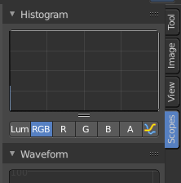

The Scopes tab contains several panels with analytic tools.

Histogram
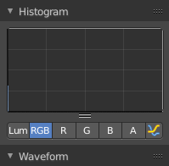
Histogram is a graph that displays the color distribution of the pixels in the image. The range from left to right goes from 0, which represents black, to 255, which represents white. And the height represents how much pixels in the image have this specific color.
The different display modes are:

Luma
Shows the luminosity of an image.

RGB
Shows the RGB channels.

R/G/B/A
Shows the R, G, B, A channels.

Show line
Displays lines instead of filled shapes.

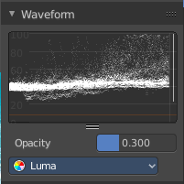
Waveform
The waveform graph is another way to display the color information of the image.

Waveform Opacity
Adjust the opacity of the pixels in the waveform histogram.

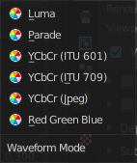
Waveform Mode
This is a dropdown box menu where you can choose further options.

Luma
Shows the luminosity of an image.

Parade
The RGB channels are shown side-by-side.

YCbCr (jpeg)
Displays the channels in the YCbCr standard, fitting to Jpg.

YCbCr (ITU 709)
Displays the channels in the YCbCr standard, fitting to ITU 709 standard.

YCbCr (ITU 601)
Displays the channels in the YCbCr standard, fitting to ITU 601 standard.

Red Green Blue
Shows the RGB channels overlaid as a “Full color” waveform.

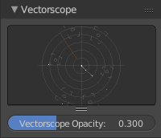
Vectorscope
This is a graph to display the pixel color distribution in the image in a radial way. The radial arrangement allows to display data that is behind the maximum 255 of the normal histogram. This can happen with 32 bit float images for example.

Vectorscope Opacity
Adjust the opacity of the pixels in the waveform histogram.

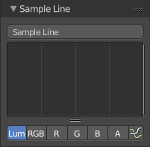
Sample Line
The Sample Line scope is a graph that allows you to get the sample data from a line.
Click at the Sample Line button above the histogram to draw a line. The pixels under this line will then be used to read the sample data from.
The different display modes are:

Luma
Shows the luminosity of an image.

RGB
Shows the RGB channels.

R/G/B/A
Shows the R, G, B, A channels.

Show line
Displays lines instead of filled shapes.

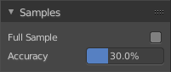
Samples
The general sample settings for the above histograms. More accurate or more fast.

Full Sample
Sample every pixel of the image.

Accuracy
Proportion of original image source pixel lines to sample.

